Another perspective on the Randers case: psychiatry is in deep crisis

Peter C Gøtzsche
Professor emeritus

10 March 2023

Translation of an article published in Jyllands Avisen and several other free Danish newspapers

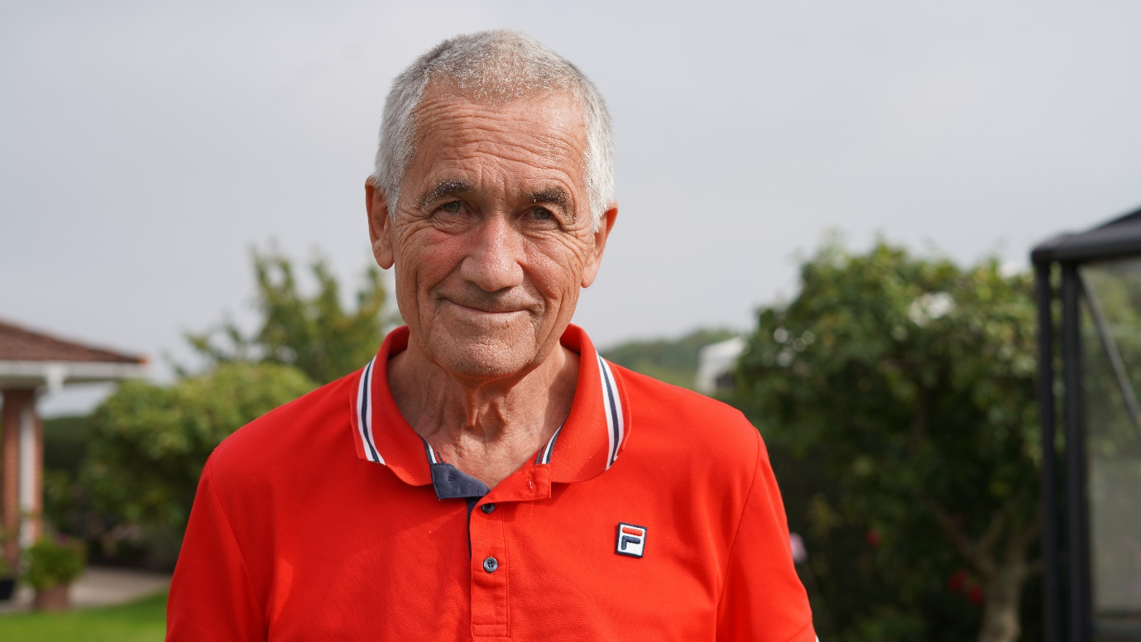

On 3 February, Karin Liltorp, MP (M), wrote in a letter to the editor in Randers Amtsavis about the case at psychiatric ward C in Randers. She believes that it is a witch hunt that has revealed deep problems in both media coverage and in psychiatry, and that the reality is far from the catastrophic scenarios that Danish national TV (DR) and other media have sold to the public.

I have long had a similar suspicion. At the end of November, Anders Heissel from DR News asked for different views on the case than those that had appeared. I wrote to him that I had good reason to suspect that something had gone completely wrong in the investigation of this case, and that I also knew the principal character.

Anders replied that my name had been mentioned by several people he had spoken to. I sent him a very informative article by journalist Gitte Rebsdorf from Psykiatriavisen from 1 December, “Psychiatry has bigger scandals than the one from Randers,” in which she writes about the fired chief physician and asks: “But what is his crime and what about all the other scandals in psychiatry? Are journalists useful idiots for a group of psychiatrists with close connections to the industry?”

I have read many psychiatric patient records, and I have never seen one where I did not find serious medical errors, in several cases to such an extent that the patient’s life was endagered. But we do not hear about that. I therefore wish to to point out that psychiatric drugs are the third leading cause of death, and there are many reasons for that.

For example, patients with psychosis always receive antipsychotics, even though they are so dangerous that they kill 2 out of 100 demented patients after just 10 weeks of treatment. We do not know how many young people they kill, because the trials conducted in schizophrenia increase the risk of death in the placebo group. The patients were already in treatment before they were randomised, which increases mortality, among other things due to suicide, since patients who are switched to placebo often experience unbearable withdrawal symptoms.

Many young people die when they are given antipsychotics. In a Norwegian study, where the patients were only 29 years old on average, 12% died within 10 years. This high excess mortality is not solely, but largely, due to the medication.

In 2006, the Danish Health Authority warned against combining antipsychotics with benzodiazepines because it increases mortality by 50-65%. But what do we see in the medical records? Virtually all patients with psychosis receive one or more antipsychotics and also benzodiazepines.

Antipsychotics should not be used at all. If the patient needs to calm down, benzodiazepines work faster, and antipsychotics - despite their name - have no specific effects on psychosis. The effect is even so poor that it is far less than the smallest effect that has any clinical relevance according to the psychiatrists themselves. I have often asked patients what they would prefer the next time they had psychosis. They have all said that they would like a benzodiazepine, but they almost never get that without also being given an antipsychotic.

It is a recurring theme in the medical records that psychiatrists don’t know how to stop psychiatric drugs. They often taper them off so quickly that some of the patients think they have gone mad. They don't think it could be a drug harm.

Psychiatry is in deep crisis. My latest book, "Is psychiatry a crime against humanity?", which can be downloaded for free from my website, begins like this (references omitted):

“We have a mental health crisis. The existing approaches that focus on drugs are not working. In the UK, mental health disability has almost trebled in recent decades, and the gap in life expectancy between people with severe mental health issues and the general population has doubled. The World Health Organisation (WHO) and the United Nations have therefore recently called for systematic mental health reform emphasising psychosocial interventions.

In 2019, a Norwegian study found that 52 of 100 consecutively admitted patients to a psychiatric hospital would have wanted a drug-free alternative if it had existed. As I shall demonstrate in this book, psychosocial interventions are clearly better than drugs. Why can’t people get that then?”

Clinical guidelines for the use of psychiatric drugs are very misleading and largely reflect the excessive influence of the pharmaceutical industry. So do the textbooks. I have read the five psychiatric textbooks most often used by Danish students. My book about this, “Critical Psychiatry Textbook,” is also available for free download on my website. It is so popular among critical psychiatrists that they have translated it into Spanish for free.

Much of what is written in textbooks and guidelines is contrary to science and directly harmful to patients. When you use such sources to find out whether the dismissed chief physician's performance of his duties in Randers can be challenged, it can only go wrong. He emphasised using drugs as little as possible, and had even set up a force-free department where patients could refuse to be treated with psychiatric drugs.

We have heard of a patient who committed suicide after being discharged from ward C, and the relatives received compensation. I asked for access to the file from the Danish Patients' Compensation Fund, but I could not get it. The case has been interpreted as if it is the fault of the dismissed chief physician, but it was not his patient, and unfortunately, we cannot prevent patients from occasionally committing suicide. But we can significantly reduce the risk if we avoid using psychiatric drugs, especially antidepressants, which double not only the risk of suicide, but also suicides, both in children and adults. Yet so-called suicide experts recommend antidepressants to patients who are at risk of suicide. This is evidence of a sick specialty. Studies in many countries have shown that when suicide prevention measures are introduced, suicides increase!

In 2017, psychiatrist Jan Vestergaard tried to get a two-hour symposium on benzodiazepines on the programme for the Danish Psychiatric Society’s annual meeting in Nyborg in March 2018 (see my latest book). Although the meeting lasted four days with parallel sessions, the board announced that there was no space. The symposium was supposed to be about addiction and withdrawal, and I was scheduled to talk about withdrawal in general, also for antidepressants and other psychiatric drugs.

I called the conference hotel in Nyborg, booked a room, and held a symposium on withdrawal of psychiatric drugs for psychiatrists in the morning, together with one of my PhD students who was researching withdrawal, which we repeated in the afternoon.

The symposia were free, but Professor of Clinical Microbiology, Niels Høiby, elected by the Liberal Alliance party as a regional council member in the capital, interfered in our altruistic initiative, even though it had nothing to do with bacteria. He raised a political issue, alleging that I had used research money for private purposes. This was a blatant lie, which Rigshospitalet had completely refuted (see my free book, “The decline and fall of the Cochrane empire”). The lies about my professional conduct were fabricated by a highly mendacious journalist, Kristian Lund, who publishes free magazines financed by the pharmaceutical industry, and therefore wanted to get rid of me.

Høiby noted that I had written a book about the use of psychiatric drugs, and that I conducted courses to get patients to taper off their psychiatric drugs. He asked whether the management of Rigshospitalet and the Capital Region, possibly in collaboration with the Danish Health Professional Council for Psychiatry, had announced to the region's psychiatrists, practicing specialists in psychiatry and general practitioners whether they "support or distance themselves from the Cochrane Center director's activities described above regarding the use of psychiatric drugs."

The region replied that Psychiatry in the Capital Region had informed all the region's centres about my activities, and that they were critical of my symposium - which they had no idea about. We had announced in the Danish medical journal that several psychiatrists had urged us to hold a course on the withdrawal of psychiatric drugs, and that "One of the greatest challenges in psychiatry is that several hundred thousand Danes are being treated with psychiatric drugs. Many of these patients would get a better life if they were withdrawn, and many want it, but cannot get professional help for it."

We met a need that the psychiatrists did not want to meet, and the symposia were a success. The most experienced psychiatrist in the room was extremely positive.

But the young psychiatrists had been warned by their bosses against participating. Clear enough. It could be difficult for them when their colleagues came back and asked good questions about why patients needed to be in treatment for years or decades instead of being phased out and having a better life.

This is frightening and shows that psychiatry is a religious cult and not a scientific discipline. In science, we are keen to listen to new research results and other points of view, which make us wiser.

The fired chief physician and his co-chief physician participated in our symposium. Their focus on using less medication and coercion than other psychiatrists was so successful that, unlike everywhere else, they had available beds. I have argued that coercion in psychiatry is a crime against humanity under international law that must be abolished, which the UN Convention on the Rights of Persons with Disabilities also recommends.

But when the chief psychiatrists from Randers wanted to talk about their methods and results in Psychiatry in the Central Region, they were not interested at all. The two chief psychiatrists were not allowed to challenge psychiatry's eternal mantra: Send more money.

I don't know the Randers case in detail, but I think it is both tragic and unfair. The only reasonable thing would be for impartial researchers to examine a number of medical records from other psychiatric departments to find out whether it is true that Department C had a lower professional standard than other departments. Based on my knowledge of psychiatry, I would expect things to be worse elsewhere. But of course, that is not going to happen. It could mean that the whole of psychiatry would collapse with a huge bang. It is much more convenient to shoot the messenger and continue business as usual.

In all countries where this relation has been studied, it has been shown that the more psychiatric drugs are used, the more patients come on disability pension. The consumption of psychiatric drugs must be drastically reduced, but leading psychiatrists are not interested in that.

In all places where pioneers have demonstrated that they get much better results by avoiding using psychiatric drugs, in Randers, Norway, Sweden and the USA, the drug-focused psychiatrists and their organisations have succeeded in having these initiatives stopped.

This must stop. We can all see that psychiatry is in deep crisis, and that the more money is poured into traditional psychiatry, the worse it gets for patients. Randers has been criticised for poor record keeping. But perhaps the doctors preferred to spend more time on the patients than on paperwork?

Karin Liltorp wrote that she had been in contact with DR to point out their one-sided coverage of the Randers case and the lack of critical questions: “The answer was discouraging: ‘There are no psychiatrists who dare come forward.’ Why? Because the fear of reprisals is apparently so great that professionals dare not speak out.”

To all of you who want to do the right thing, but don’t dare: Come out of your hide so that you can look yourselves in the eye in the evening. If you stand together, you can become strong.

