Janus Bang, MA

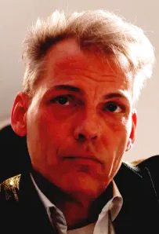

Janus Bang, MA, is a historian who has produced and worked on several documentaries for Danish Television. He is best known for his research and filming in areas related to psychiatry, the welfare state and politics. Since 2015, he has been documenting and filming about evidence-based medicine all over the world, taking a special interest in the issues scientists face and other problems in this field. Towards the end of the COVID-19 pandemic, he established the non-profit evidence-based film and interview channel Broken Medical Science in collaboration with Professor emeritus Peter C Gøtzsche. This was due to the censorship and suppression of free speech, targeted towards scientists all over the world. The channel features interviews and programmes with some of the world’s most prominent medical researchers. Documenting the challenges facing the scientific community has become one of his primary goals, with a combination of scientific historical methods and the knowledge of Gøtzsche, known as one of the most outspoken scientists in medicine.

