**Do antidepressants work? This British professor says they don’t**

Joanna Moncrieff is a professor and NHS psychiatrist who dared to argue that depression is not a physical illness. As a result she has been abused by peers — and championed by Tucker Carlson. Is her theory right?

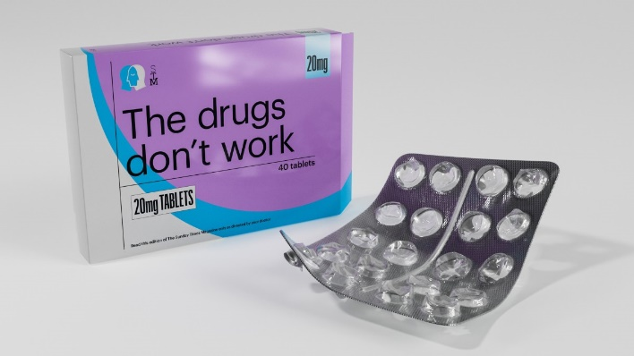

LISA SHEEHAN FOR THE SUNDAY TIMES MAGAZINE

[Julia Llewellyn Smith](https://archive.md/o/yOZHJ/https:/www.thetimes.com/profile/julia-llewellyn-smith)

Sunday January 12 2025, 12.04am GMT, The Sunday Times

When Joanna Moncrieff published her paper *The Serotonin Theory of Depression: A Systematic Umbrella Review of the Evidence* three years ago in the journal Molecular Psychiatry, it made headlines around the world and rapidly became one of the most widely read scientific papers of recent times.

Moncrieff, 58, is a professor of critical and social psychiatry at University College London and an NHS psychiatrist. The conclusion of her 2022 paper, which was based on the 17 main studies into the link between the “happy hormone” serotonin and depression, was that there was “no evidence” that low amounts of the former caused the latter.

By extension, Moncrieff was exploding the theory, propounded for decades, that commonly prescribed antidepressants — specifically selective serotonin reuptake inhibitors (SSRIs) — can “cure” depression by rectifying a chemical imbalance in the brain.

“I’m not convinced antidepressants have any use,” she tells me. “I spend a lot of time telling people the answer is not a drug, there isn’t a miracle cure out there. It isn’t necessarily what people want to hear. It’s quite a hard thing to take, and a lot of people feel they’re being abandoned.”

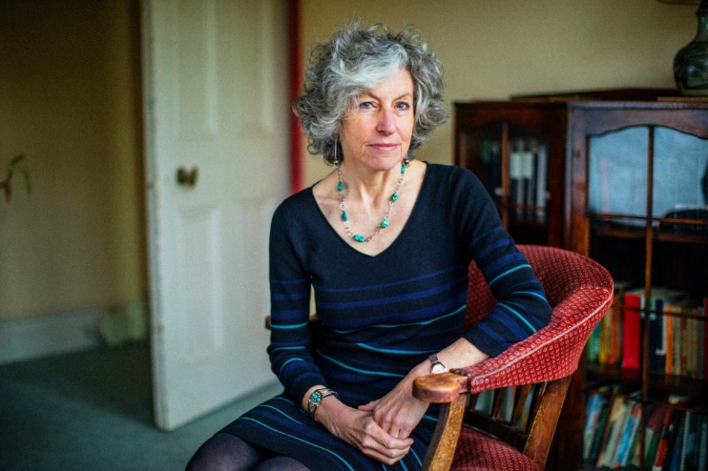

Joanna Moncrieff, 58

LAURA PANNACK FOR THE SUNDAY TIMES MAGAZINE

Immediately after her paper was published, Moncrieff began receiving online abuse. Articles were published accusing her of being a far-right sympathiser and conspiracy theorist. Dr James Rucker, a psychiatrist at King’s College London, later posted unsubstantiated allegations on Twitter (now X): “Today sees the first patient of mine who has killed themselves because of the narrative you inspire people to spread about antidepressants. Congratulations and welcome to your new world Joanna. I’ll be sure to share the good news with the coroner when I see them.”

“I was accused of ‘pill shaming’, making people feel bad about taking pills because I’d pointed out negative consequences. People said, ‘You’re cruel to publish this review,’” Moncrieff says. “It’s a completely nonsensical position. You’re taking something and you don’t want to know about [potential] side-effects such as permanent sexual dysfunction? What’s that about? It was so shocking and depressing.”

Antidepressants were taken by 8.7 million people in England in 2023, a figure that had increased by 16 per cent over five years. Millions insist these drugs have alleviated their suffering. It’s no wonder she has caused a furore. Moncrieff believes the people who have been prescribed these drugs have been duped — by insecure psychiatrists and greedy drug companies.

As she writes in her new book, *Chemically Imbalanced*: “The quest for money and professional status, the hubris of the scientific community and the quiet desperation of so many has combined to create one of the most widespread delusions of recent times: the idea that emotional problems can be resolved with a pill.” Not only does she consider antidepressants ineffective, she has also warned for decades about sometimes hugely severe side-effects. Yet for highlighting these risks Moncrieff has been attacked on social media and by colleagues. “It’s not my intention to stop people taking antidepressants or starting them if they want to. I want people to know exactly what risk they are running. If you choose not to read the studies that’s fine, but to suggest they shouldn’t be out there it’s like suggesting we shouldn’t have let anyone know about thalidomide.”

Soft-spoken, gentle in demeanour but unwavering in her opinions, Moncrieff is sitting in jeans and a jumper in the slightly ageing kitchen of her house in Brentwood, Essex, near the former asylum where she held her first consultant post.

As a founder and co-chair of the Critical Psychiatry Network, she’s notorious among her peers for questioning their medical approach to mental illness. Having “always considered myself on the left”, she has recently found that many of those she thought shared her political leanings are decrying her criticisms of “big pharma” and the pathologising of normal human sadness.

Often these were the same people who until recently had supported her view that the real causes of mental illness are social issues such as poverty and racism. “But now if you question the idea that depression is simply a brain problem, you’re a flat-earther,” she says. The debate, she adds, tipped from scientific to ideological “in the past five or ten years. People have bought into an identity of being someone with a brain disorder. It’s a symptom of how insecure we all feel.”

Right-wing media, to Moncrieff’s unease, leapt on her findings. The controversial American political host Tucker Carlson covered her serotonin study on his Fox News talk show. “When I heard I was horrified,” Moncrieff says. “But then I watched and thought, actually, this is really quite a good programme. Carlson’s asking some very important questions about the nature of drugs and the pharmaceutical industry.”

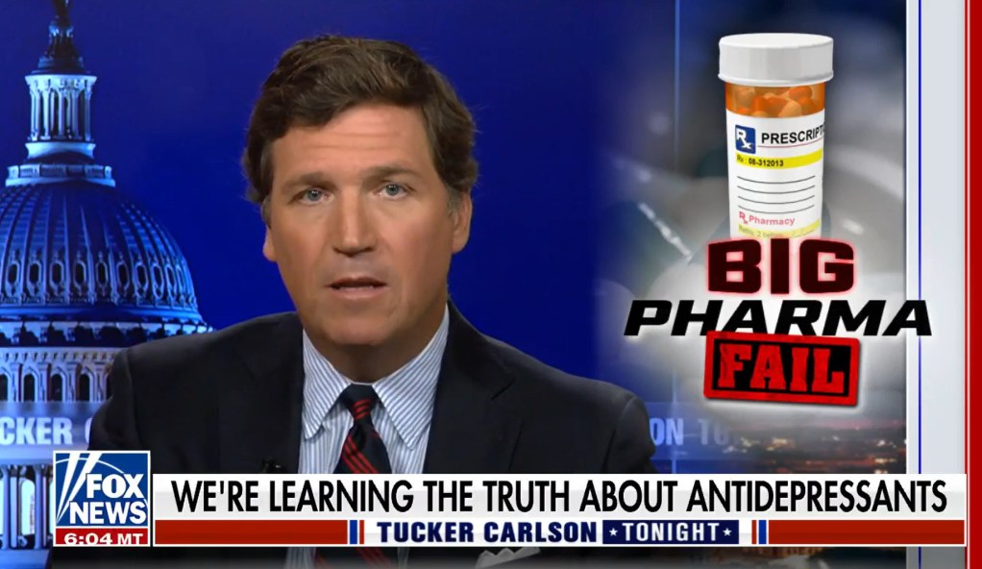

Tucker Carlson covers Moncrieff’s findings on his Fox News show in 2022

In return Rolling Stone published an article titled “Who is the psychiatrist behind the antidepressant study taking over right-wing media?” The magazine noted her work was propounded by organisations funded by Scientology (Moncrieff says she has no links with the religion) and accused her of “promoting” the “fringe” idea SSRIs might cause aggression in young people, a line used by the gun lobby — and espoused by Robert F Kennedy Jr, the president-elect Donald Trump’s pick for health secretary — to explain the causes of school shootings and argue against gun control. In reality, Moncrieff — who strongly supports gun control — had discussed another study on the link between aggression and SSRI use in the mainstream British Medical Journal, with her cautious view being that the public needed more data on the issue.

“It was bizarre, gutter journalism,” Moncrieff says. “But the article manifested the reaction of people who don’t want to know, who are really cross about having their world view questioned.”

Antidepressants were invented only by accident, after US pharmaceutical company scientists searching for a tuberculosis cure in 1952 noted patients became more cheerful after taking the anti-infection drugs they were developing. Nobody understood how these drugs worked, but since mental illnesses were usually tackled through partial lobotomies, brain injections or electroshock treatment, a straightforward pill was a hugely appealing alternative.

The theory was that depression was caused by a chemical imbalance that drugs could cure. Over the following decades this theory has been refined but never conclusively proven. Moncrieff and other sceptics argue the drugs may create a chemical imbalance, with the body changing its biological structure and activity in response to them, which is why many find it so difficult to wean themselves off them.

At work she occasionally prescribes sedatives to help agitated patients who can’t sleep and antipsychotics to people with schizophrenia. Yet depression, she maintains, is largely a normal reaction to adverse circumstances. Individual biology may make some of us more prone to low moods than others — but the components are too subtle to be targeted by a drug.

Moncrieff acknowledges antidepressants change our mental states, but argues that they do so by altering normal brain activity not by correcting a physiological chemical imbalance or other biological abnormality. For most antidepressants these changes result in a dampening of emotional intensity, which some might experience as useful, although others find it unnerving or unpleasant. One 2006 study showed that 85 per cent of depressive episodes clear up without intervention within a year.

• [**I came off antidepressants. Then I couldn’t cope**](https://archive.md/o/yOZHJ/https:/www.thetimes.com/article/i-came-off-antidepressants-then-i-couldnt-cope-7t807wbzf)

“But the majority of psychiatrists want to believe the drugs are rectifying something in the brain, regardless of whether we know what that is or not, because the idea of giving someone who’s depressed something that numbs you is uncomfortable — it’s a bit like telling someone to go and get drunk or take an opiate,” Moncrieff says.

She is also deeply concerned about the side-effects of antidepressants, highlighted recently by the suicide of Thomas Kingston, husband of the King’s second cousin Lady Gabriella Kingston, who told an inquest that she believed his death last year was “highly likely” to have been provoked by an adverse reaction to the widely prescribed SSRI citalopram. Stated possible side-effects of citalopram include loss of libido, which can lead to persistent sexual dysfunction, fatigue, dizziness, digestive problems and — counterintuitively — acute anxiety.

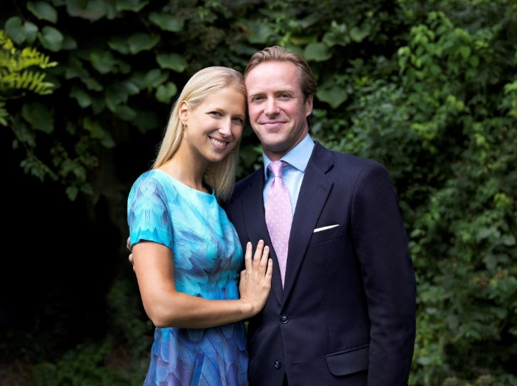

Lady Gabriella Kingston believes her husband, Thomas Kingston, suffered an adverse reaction to the antidepressant citalopram that led him to take his own life last year

ALEXANDRA DIEZ DE RIVERA / BUCKINGHAM PALACE / REUTERS

Then there’s withdrawal. Antidepressants were originally marketed as nonaddictive, yet a recent study in The Lancet showed one in six people struggle to quit them, with symptoms including dizziness, headaches, nausea and insomnia. The same study showed that for one in thirty-five the mental and physical pain caused by withdrawal is severe, causing many to return to taking them. Research by *Panorama* in 2023 revealed two million people in England had been on antidepressants for more than five years, one million more than five years previously, even though the drugs are meant to be taken only in the short term. Moncrieff stresses anyone thinking of stopping antidepressants should seek medical advice and should never stop them abruptly.

• [**Thomas Kingston inquest: wife’s warning over antidepressants**](https://archive.md/o/yOZHJ/https:/www.thetimes.com/article/thomas-kingston-death-inquiry-medication-7rkbvn622)

Single, with three adult children, Moncrieff grew up in Oxford the daughter of a paediatrician. Aged 14, a pupil at a private girls’ school “where I didn’t feel I fitted in”, she went through her own phase of depression, with symptoms including difficulty sleeping, loss of pleasure, waking up with a sinking feeling and doubts she wanted to carry on living.

“Looking back I was a pretty stereotypical teenager, full of burning questions about the meaning of life that I felt no one else cared about, but still desperate for friends,” she says. This was the 1980s, so the notion of seeking medical help was alien. In any case, “I had a sense that seeing this as a medical problem wouldn’t help. I had a fear of taking anything that might cloud my mind. I didn’t know quite what was wrong, but I thought I needed to change my life in some way.”

In the end she moved to a sixth form at a nearby comprehensive, where “I had a whale of a time and was happy again”.

She is aware her example is inadequate as an argument for everyone shunning antidepressants. Yet generally she believes circumstances rather than chemistry make us depressed. “But making changes in your life is difficult and scary, so of course it’s easier at some level to be told to take a pill.”

Unsure what she wanted to do as a career, she wound up studying medicine at Newcastle University. Inspired by the works of psychiatrists such as RD Laing and Thomas Szasz, who viewed mental illness as a political and social construct rather than a biological issue, she decided to follow them into their field. As a junior psychiatrist at St George’s Hospital in Morpeth, Northumberland, she was shocked by the condition of patients she observed on psychiatric wards. “People were shuffling around zombified, clearly massively drugged with all sorts of obvious side-effects. It didn’t seem to me that we were curing people in the way presented in the textbooks.”

Working with outpatients who were on antidepressants made her even more sceptical. “Some improved a bit but usually there was some other explanation as to why they’d got better. It didn’t seem clear the drugs were doing anything.”

• [**Psychiatrist became dependent on antidepressants — now, he helps others to quit**](https://archive.md/o/yOZHJ/https:/www.thetimes.com/article/the-psychiatrist-who-got-hooked-on-antidepressants-now-he-helps-others-to-quit-0k8dsnsxb)

Moncrieff was working as a junior doctor at the Warley Hospital in Essex when in 1992 the Royal College of Psychiatrists and the Royal College of General Practitioners launched the “defeat depression” campaign to explain the condition as a medical disorder. It was partly funded by the US pharmaceutical giant Eli Lilly, which had recently licensed a new drug, Prozac. Over the next decade prescriptions for antidepressants in the UK increased by 235 per cent. “I remember thinking, ‘Oh my goodness, this is ludicrous,’ being embarrassed our profession was doing the job of promoting Eli Lilly.”

She compares this marketing campaign from antidepressant manufacturers to that recounted in the Disney+ drama *Dopesick*, in which another US drugs giant, Purdue Pharma, heavily promoted its painkiller OxyContin as not addictive, igniting the country’s devastating opioid crisis.

“Doctors could and should have been stopping this, standing up and saying, ‘It doesn’t make sense to have a nonaddictive opioid.’ And they should have been standing up to pharma, saying, ‘There’s no evidence of a serotonin imbalance. There’s no evidence that antidepressants correct anything. This is misleading.’”

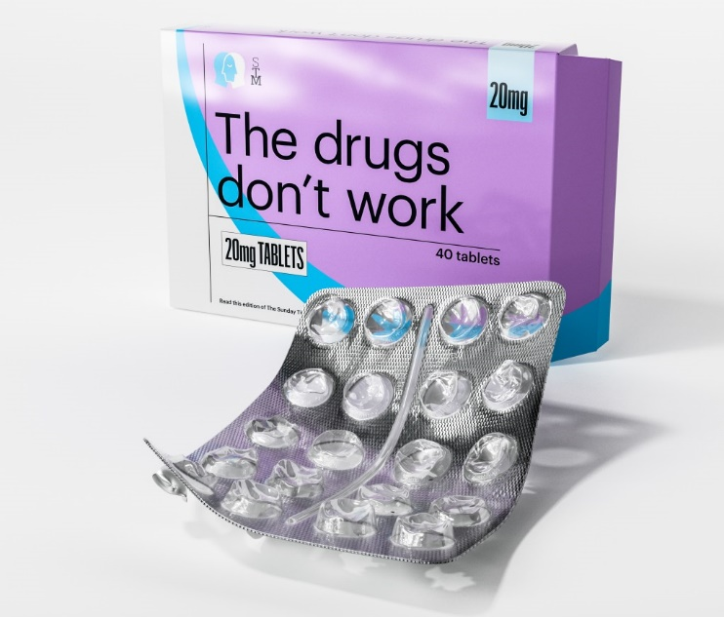

LISA SHEEHAN FOR THE SUNDAY TIMES MAGAZINE

Moncrieff’s studies, as with those of any published scientist, are subject to rigorous, author-blind peer reviews. Yet nearly a year after her serotonin-debunking paper was published, 36 researchers led by Sameer Jauhar, a senior clinical lecturer in affective disorders and psychosis at the Institute of Psychiatry, Psychology and Neuroscience at King’s College London, published a response in Molecular Psychiatry arguing that there were methodological weaknesses in Moncrieff’s review process, including oversimplification, selective reporting of data and errors in the interpretation of neuropsychopharmacological findings.

Moncrieff addressed the criticism in two lengthy articles published in the same journal a month later. She says that the assertions by Jauhar and many others didn’t debunk her theory that there was no proven link between serotonin and depression; rather they were scoffing it was old news and added nothing new to the debate.

Jauhar tells me his paper was not an “attack” on Moncrieff. “To my mind, anyone who works in psychiatry doesn’t do it for the money, they do it because they care about people with severe mental illness. This was a comment on science and what the science showed. Taking someone else’s review [as Moncrieff did] and having a difference of opinion on them is fine, but I would consider that quite brave because I haven’t put in the original work into conducting the study.”

Shortly before Moncrieff’s study was published, the National Institute for Clinical Excellence (Nice) guidelines concluded that antidepressants can be helpful in cases of moderate to severe depression. Neil Nixon is a consultant psychiatrist and associate professor at the Institute of Mental Health in Nottingham. He says: “I’ve seen repeatedly how transformative antidepressants can be, alongside things such as cognitive behavioural therapy [CBT].

“Nobody serious about psychiatry imagines it’s all about the specific imbalance of a particular chemical. Serotonin is likely to remain a part of the picture but within a much more complex understanding of how the brain works. There are antidepressants that don’t rely on serotonin at all, so it feels a bit like tilting at windmills to say that’s all this is about.”

Moncrieff argues back that theories of “complex interactions” are not supported by convincing evidence either. “Essentially they’re all a way of convincing people to take prescription drugs,” she says.

Nixon’s concern is for the effect this debate is having on his patients, who, he stresses, have gone way beyond normal sadness to a place where they’re depressed every day for very long periods. “It’s very unhelpful. Professionals are throwing rocks at each other and patients are caught in the middle often when they are already in confused, unwell states, and not sure what to make of it.”

• [**Isolde Waters: For me, the antidepressants worked. Coming off them was terrifying**](https://archive.md/o/yOZHJ/https:/www.thetimes.com/article/antidpressants-experience-pills-thomas-kingston-sx79k7qjz)

For Moncrieff, protecting feelings is less important than facts. Have her views impeded her career? “I probably haven’t had as many big grants as other professors in the department,” she says.

In 2020 Wendy Burn, then president of the Royal College of Psychiatrists, admitted that health problems associated with coming off antidepressants were “widely underrecognised”, after which it published its first leaflet advising patients on safe withdrawal. Nice guidelines from 2022 now state GPs should inform patients of possible side-effects and review responses within two weeks of starting a course of antidepressants.

GPs are now encouraged to push the likes of “talking” CBT over pills for milder depression. The swing away from drugs, in Moncrieff’s opinion, is linked to the fact most patents for antidepressants have expired, meaning they are no longer money-spinners for drug companies.

Moncrieff is clear there is no shame in suffering from mental illness. But she believes the best approach to tackling it is through talking therapies, exercise and a willingness to make appropriate changes in one’s life. “But a very neuro-reductionist view of mental health problems and life in general is particularly gaining traction among young people. It trumps everything else. Why have marital therapy if your brain is the problem?

“For most people, things in their lives will get better or they will come out of whatever it was that was making them low. But if they attribute that to a drug, they don’t learn that in fact these things pass and they might be able to do something about it themselves.”

***Chemically Imbalanced: The Making and Unmaking of the Serotonin Myth* by Joanna Moncrieff is out on Thursday (Flint £20). To order a copy go to**[**timesbookshop.co.uk**](https://archive.md/o/yOZHJ/https:/timesbookshop.co.uk/chemically-imbalanced-9781803996790/)**. Free UK standard P&P on orders over £25. Special discount available for Times+ members**